Password Reset Directions
- https://passwordreset.microsoftonline.com/

- Follow the link above and enter your full email address. Warriormail address for Students, or rlc.edu email for Faculty/Staff. Complete the captcha and click Next.

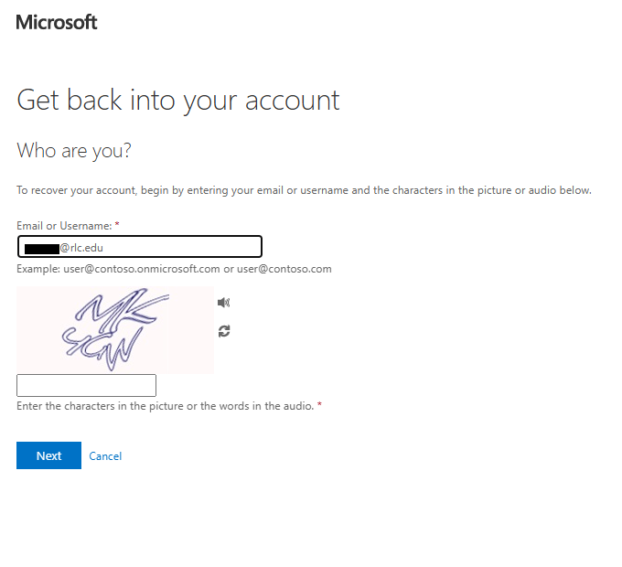

- Select the preferred method of verification. It will offer multiple options to choose from.
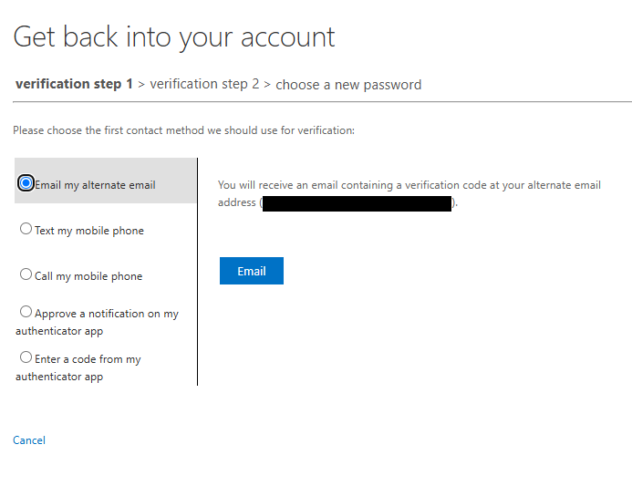

- Choose the second method of verification.
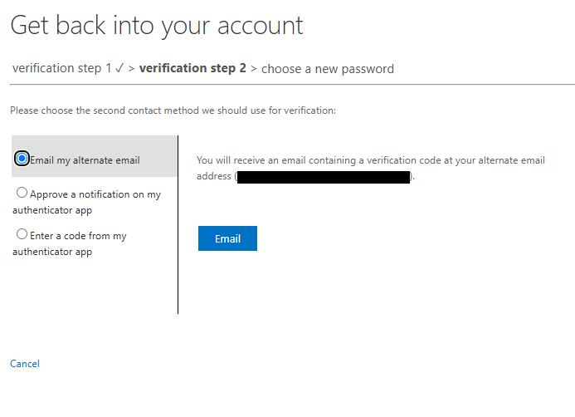

- Once verification is complete, you can reset your password. Enter your new password on the first line and then enter it again on the second line to confirm your new password. Click Finish to save the new password.
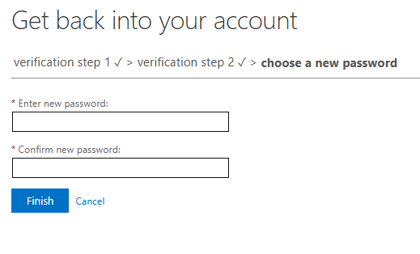

If you need any further assistance, you may contact the Help Desk at 618-437-5321 ext. 1259 or by email at Help-Desk@rlc.edu.

Please remember, do NOT provide sensitive information (i.e. username or password) in the email. A name, phone number, and brief description are all that should be included with the email.

